
UNIVERSIDAD NACIONAL MAYOR DE SAN MARCOS

Doctoral Program in Deep Tech, Artificial Intelligence & Emerging Technologies

Research Methods and Scientific Integrity in AI and Advanced Technologies
DELIVERABLE No. 4: Systematic Review

Course Instructor: Dr. Loveleen Gaur

Student: Félix Richar Mendoza Pumacahua

2026 - II

Mini Systematic Review

10 papers, identified through your documented search string in Semantic Scholar (or Scopus / WoS if you have access)
Research question and scope
This mini systematic review looks at how recent literature (2022–2026) proposes reference architectures, enterprise architecture and architectural frameworks to integrate generative and agentic AI (LLMs, agents, multi-agent systems) into software development in a governed way, and which mechanisms of compliance, verification and governance they use. Guiding question: What architectures and governance mechanisms have been proposed to ensure compliance when generative/agentic AI is used in the software development life cycle, and what level of empirical validation do they have?
The question is aligned with my doctoral problem: how to govern the use of AI in the development of solutions on top of an institutional reference architecture (application case: the Integrated Pension Information System (SIIP) of the Pension Normalization Office (ONP), whose Reference Architecture requires an Architectural Conformance Assessment (ECA) before development starts and explicitly includes artificial intelligence solutions in its scope).
Search strategy
Database: Scopus (TITLE-ABS-KEY fields). Time filter: PUBYEAR > 2021. Result: 17 documents. Execution date: [complete with the date of your query].
TITLE-ABS-KEY(("generative AI" OR genAI OR "large language model*" OR LLM* OR "agentic AI" OR "AI agent*" OR "LLM agent*" OR "multi-agent") AND ("reference architecture*" OR "enterprise architecture" OR "architectural framework*" OR TOGAF OR ArchiMate) AND ("software development" OR "software engineering" OR "code generation" OR SDLC) AND (complian* OR regulat* OR verif* OR validat* OR governance)) AND PUBYEAR > 2021
The string combines four conceptual blocks (generative/agentic AI · reference/enterprise architecture · software development · compliance/governance) joined with AND. The synonyms inside each block are joined with OR, and wildcards are used to cover word variants.
Eligibility criteria and selection procedure
Inclusion | Exclusion
IC1. It addresses generative AI, LLMs or AI agents.  IC2. It proposes, evaluates or discusses a reference architecture, enterprise architecture, framework or architectural patterns.  IC3. It is set in software engineering / SDLC or in the enterprise integration of these systems.  IC4. It deals with compliance, verification, security or governance.  IC5. Published between 2022 and 2026 and peer reviewed (article or conference paper). | EC1. Duplicates.  EC2. Records without accessible text or without abstract.  EC3. Works that use AI only as an analysis tool, with no architectural or governance component.  EC4. Language other than English or Spanish.  EC5. Grey literature, theses or chapters without peer review.

Procedure. Scopus returned 17 documents. For this mini review, I took the first 10 records of the list in the default Scopus order (results 1–10 of 17), because the deliverable asks for 10 papers. The remaining 7 records are outside the sample and are reported as excluded in the PRISMA diagram.

Included studies (n = 10)

# | Reference | Focus / contribution
1 | Bandeira, De Oliveira, Maia, Aderaldo & Mendonça (2026). LLM-Native Applications: Toward a New Paradigm in Software Engineering. ICSE Companion 2026. Conference paper. | Software engineering paradigm for LLM-native applications.
2 | Alenezi, Akour & Al-Omari (2026). Agentic AI in Software Engineering: Integration Points, Architectural Frameworks, Empirical Evaluation, and Governance. International Journal of Technology, 17(4). Article. | Framework to integrate agentic AI into development; systematic review + multi-case analysis of 4 enterprise projects (pre/post, Wilcoxon). It reduces cycle time by 40–55%, MTTR by 33–48% and change failures by 7–11%, with no compliance violations. Stated limitation: the results are specific to the context and based on few projects.
3 | Elsisi, Santos & Melo (2026). Lifecycle-Aware GenAI Assistance with MCP via Context Refinement Loops: A Reference Architecture. FSE Companion 2026. Conference paper. | Reference architecture for GenAI assistance across the life cycle, using MCP and context refinement loops.
4 | Stein (2026). Toward a taxonomy of generative AI use cases in business contexts: Integrating complexity, risk, and strategy. Journal of Computational Science, 96, 102826. Article. | Four-layer complexity taxonomy (A: prompt-based assistants; B: reproducible code generation; C: text generation in production; D: autonomous agents that call tools) and five perspectives (context, value, strategy, technical autonomy, data governance). It separates layer C from layer D as a “phase change” in autonomy and risk.
5 | Kushnerov, Sokol, Akhiiezer, … Nadtochyi & Balagura (2026). Zero-trust Conceptual Architecture for Secure Integration of Large Language Models and Autonomous AI Agents. ICHORA 2026. Conference paper. | Conceptual zero-trust architecture to integrate LLMs and autonomous agents in a secure way.
6 | Siddhu, Pappu & Thanvi (2026). Compliance-Aware Generative AI for Life Insurance Document Synthesis: A Reference Architecture. ICAISET 2026. Conference paper. | GenAI reference architecture that is aware of compliance in a regulated domain (life insurance).
7 | Karuppuchamy (2026). Governed Agentic AI for Software Platforms: A Reference Architecture for Safe Autonomy at Scale. IEEE SoutheastCon 2026. Conference paper. | Reference architecture for governed agentic AI in software platforms (safe autonomy at scale).
8 | Moriarty (2026). From Classroom to Enterprise: Architectural Patterns for LLM Integration. IEEE SysCon 2026. Conference paper. | Architectural patterns to integrate LLMs, from the academic setting to the enterprise.
9 | Enyedi (2026). Human-Certified Module Repositories for the AI Age. IEEE AQTR 2026. Conference paper. (Abstract read in the arXiv:2603.02512 preprint.) | Repositories of curated modules, reviewed for security, with provenance and explicit interface contracts; it combines human judgment and automatic analysis to certify modules. It presents a reference design, analyzes vulnerabilities and addresses governance and scalability.
10 | Pokala (2026). Agentic Dashboard Generation from Natural Language on Lakehouse Platforms. ICAISET 2026. Conference paper. | Agentic generation of dashboards from natural language on lakehouse platforms.

Synthesis of findings
• Architectural proposals dominate. 7 of 10 studies present an architectural artifact (reference or conceptual architecture, framework or patterns): #2, #3, #5, #6, #7, #8 and #9.
• Governance and compliance are a recurring topic. They appear explicitly in 6 of 10 studies (#2, #4, #5, #6, #7 and #9), with approaches that go from zero-trust and module certification to risk taxonomies.
• Application contexts. Enterprise and business settings dominate; the only regulated domain that appears explicitly in the titles is insurance (#6). No title mentions digital government or social security.
• Maturity of the field. All 10 studies are from 2026 (8 conference papers and 2 journal articles), which suggests an emerging field that is not yet consolidated.
Limitations of this review
(i) Only one database (Scopus); (ii) a sample of 10 out of 17 records, selected by order of appearance and not by relevance screening; (iii) for 7 of 10 studies the reading was limited to title and metadata; (iv) no formal quality assessment of the studies was applied. These points should be improved in the full review by expanding to IEEE Xplore, ACM DL and Web of Science and by applying double screening.
Links to the studies
• #1 (ICSE Companion): https://dl.acm.org/doi/10.1145/3774748.3795680
• #2 (Alenezi et al.): https://ijtech.eng.ui.ac.id/article/view/8380
• #3 (FSE Companion): https://dl.acm.org/doi/10.1145/3803437.3805617
• #4 (Stein): https://www.sciencedirect.com/science/article/pii/S187775032600044X
• #7 (Karuppuchamy): https://ieeexplore.ieee.org/document/11475963
• IEEE Xplore, still to be assigned to studies #5, #6, #8, #9 and #10 (4 links were recorded for 5 studies): /document/11537001, /document/11541931, /document/11503623, /document/11577868. Study #9 is also available as arXiv:2603.02512.

PRISMA 2020 Flow Diagram
Diagram built following the official template PRISMA 2020 flow diagram for new systematic reviews which included searches of databases and registers only (Page et al., 2021). The four phases (identification, screening, eligibility and inclusion) have non-empty values that are consistent with each other.
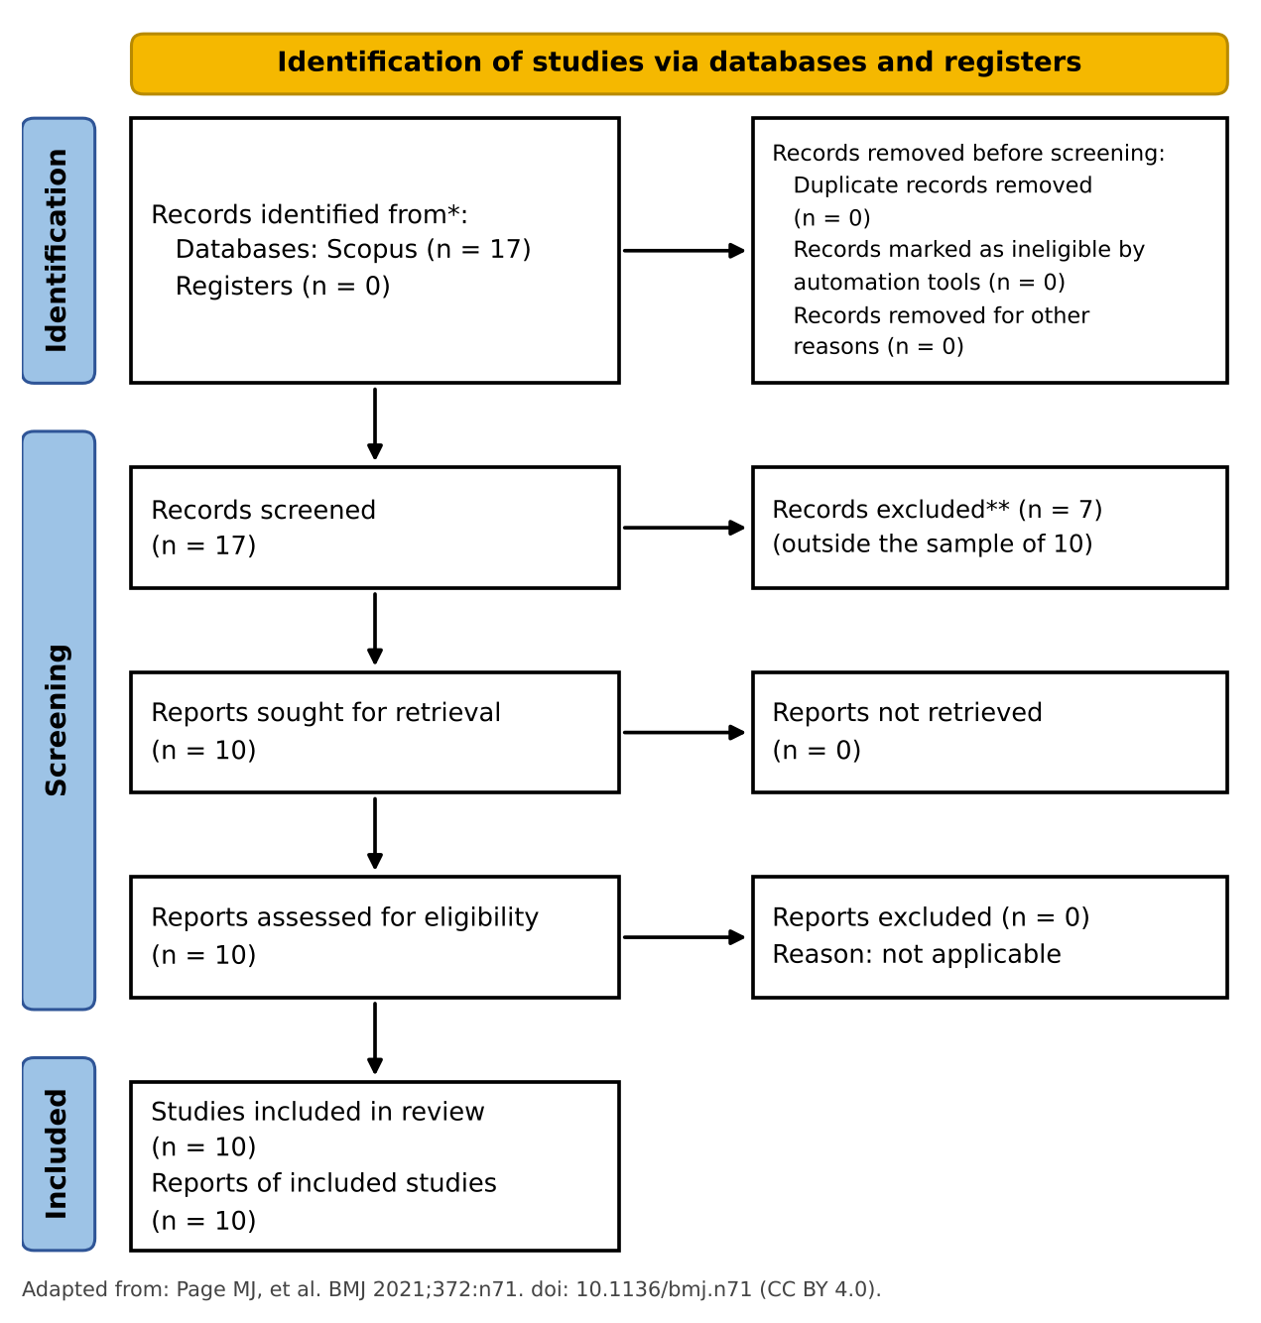
Figure 1. PRISMA 2020 flow diagram of the mini systematic review. Source: own elaboration, adapted from Page et al. (2021).

Gap Analysis Table

At least one candidate gap per type (knowledge · methodological · contextual · theoretical) with a citation as evidence.
At least one candidate gap was identified for each type.
Gap type | Candidate gap | Evidence (citation) | Research opportunity
Knowledge | There is little evidence on whether the use of agentic AI in the SDLC stays compliant with formal standards and architectures in contexts other than private enterprise projects. | Alenezi et al. (2026): reports “no compliance violations” in 4 enterprise projects, but warns that the findings are “context-specific and derived from a limited number of enterprise projects”. | Study AI compliance in development under a mandatory architectural framework, in a public entity with several software factories.
Methodological | Most proposals are architectures with weak or undeclared empirical validation; the few evaluations use few cases and quasi-experimental designs. | Alenezi et al. (2026): results are “indicative rather than broadly generalizable”, and stronger quasi-experimental validation is needed. Enyedi (2026): the abstract presents a reference design and a vulnerability analysis, with no declared empirical evaluation. Elsisi et al. (2026), Siddhu et al. (2026) and Karuppuchamy (2026) have “reference architecture” in their titles (to be confirmed). | Design Science Research approach: build a governance artifact and evaluate it in cycles, with compliance metrics (e.g., a conformance score) and a before/after comparison or a control group.
Contextual | The corpus is concentrated on enterprise and commercial settings; the public sector and social security systems, with legacy system coexistence and State interoperability obligations, do not appear. | Alenezi et al. (2026): enterprise projects. Siddhu et al. (2026): life insurance, the only regulated domain. Stein (2026): business contexts. None of the 10 titles mentions digital government, the public sector or social security. | SIIP–ONP case: AI in development under the Reference Architecture, with the ECA, legacy coexistence and Peruvian digital government regulations. Verify the gap with the 7 records not analyzed and with additional databases.
Theoretical | There are taxonomies of autonomy/risk and governance proposals, but no theory that links the autonomy levels of AI with the conformance criteria of a reference architecture (TOGAF/ArchiMate). | Stein (2026): A–D taxonomy, with layer D described as “a fundamental phase change in system autonomy”; the abstract does not relate it to enterprise architecture frameworks. Karuppuchamy (2026) and Kushnerov et al. (2026) propose governed/zero-trust architectures (by title), with no declared mapping to architectural conformance. | Theoretical framework that associates each autonomy level (A–D) with controls, artifacts and architecture governance milestones (e.g., dimensions D1–D5 of the ECA), and submits it to validation.

References
Alenezi, M., Akour, M., & Al-Omari, O. (2026). Agentic artificial intelligence in software engineering: Integration points, architectural frameworks, empirical evaluation, and governance. International Journal of Technology, 17(4). https://ijtech.eng.ui.ac.id/article/view/8380
Bandeira, A. P., De Oliveira, G. L. B., Maia, P. H. M., Aderaldo, C., & Mendonça, N. (2026). LLM-native applications: Toward a new paradigm in software engineering. In Proceedings of the 48th IEEE/ACM International Conference on Software Engineering: Companion Proceedings (ICSE Companion 2026). https://doi.org/10.1145/3774748.3795680
Elsisi, O., Santos, F. D. A., & Melo, G. (2026). Lifecycle-aware GenAI assistance with MCP via context refinement loops: A reference architecture. In FSE Companion 2026: Proceedings of the 34th ACM International Conference on the Foundations of Software Engineering. https://doi.org/10.1145/3803437.3805617
Enyedi, S. (2026). Human-certified module repositories for the AI age. In IEEE International Conference on Automation, Quality and Testing, Robotics (AQTR 2026). arXiv:2603.02512.
Karuppuchamy, S. (2026). Governed agentic AI for software platforms: A reference architecture for safe autonomy at scale. In IEEE SoutheastCon 2026. https://ieeexplore.ieee.org/document/11475963
Kushnerov, O., Sokol, V., Akhiiezer, O., … Nadtochyi, M., & Balagura, D. (2026). Zero-trust conceptual architecture for secure integration of large language models and autonomous AI agents. In ICHORA 2026 (8th International Congress on Human-Computer Interaction, Optimization and Robotic Applications).
Moriarty, B. (2026). From classroom to enterprise: Architectural patterns for LLM integration. In IEEE SysCon 2026 (20th Annual IEEE International Systems Conference).
Page, M. J., McKenzie, J. E., Bossuyt, P. M., et al. (2021). The PRISMA 2020 statement: An updated guideline for reporting systematic reviews. BMJ, 372, n71. https://doi.org/10.1136/bmj.n71
Pokala, H. K. (2026). Agentic dashboard generation from natural language on lakehouse platforms. In ICAISET 2026 (International Conference on Artificial Intelligence Systems and Emerging Technologies).
Siddhu, H. S., Pappu, K., & Thanvi, Y. S. (2026). Compliance-aware generative AI for life insurance document synthesis: A reference architecture. In ICAISET 2026.
Stein, H. (2026). Toward a taxonomy of generative AI use cases in business contexts: Integrating complexity, risk, and strategy. Journal of Computational Science, 96, 102826. https://www.sciencedirect.com/science/article/pii/S187775032600044X

